**30**

**Faraday’s Law and Inductance**

|  |
| --- |
| **CHAPTER OUTLINE** |

30.1 Faraday’s Law of Induction

30.2 Motional emf

30.3 Lenz’s Law

30.4 The General Form of Faraday’s Law

30.5 Generators and Motors

30.6 Eddy Currents

* An asterisk indicates a question or problem new to this edition.

|  |
| --- |
| **ANSWERS TO THINK – PAIR – SHARE ACTIVITIES** |

**\*TP30.1** To determine the sense of rotation for a given configuration, let’s assume that the upper surface of the disk magnet is the north pole. The magnetic field lines from the magnet will be similar to those of the bar magnet in Figure 30.22. Let us look closely at the screw, as in the diagram below:

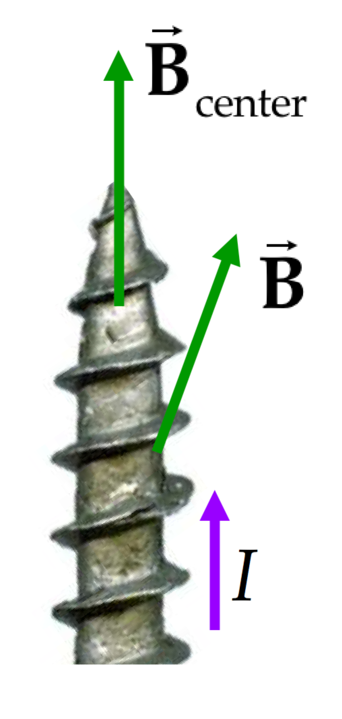

Because the top button of the battery is the positive terminal, the current is directed upward in the screw. Assuming that the magnet is centered on the screw head, the magnetic field line along the center of the screw is vertically upward. But look at a point in the screw close to its outer edge on the right. Because of the shape of the magnetic field lines from the disk magnet, the field line is tilted outward at this location. We assume that the current is directed upward at all points within the screw. Therefore, applying the cross product in Equation 28.10, we see that there is a magnetic force directed into the page at this location. Such a tangential force will be applied at all locations off the centerline of the screw. As a result, the screw will rotate counter clockwise if viewed from overhead.

(a) If the disk magnet is turned over, the upper edge of the magnet is the south pole. This will reverse the direction of the magnet field vectors in the diagram, and the rotation will reverse.

(b) If the battery is turned over, this process interchanges the terminals of the battery, causing the current to be downward in the screw. This will again reverse the sense of rotation of the screw.]

*Answers:* (a) The sense of rotation should reverse. (b) The sense of rotation should reverse again.

**\*TP30.2 Conceptualize** Make sure you understand how the apparatus works. Notice that only one metal rod at a time is between the poles of the magnet. Therefore, the number of metal rods is not important electrically. Having a large number is important mechanically, because you want one rod to enter the magnetic field just as another leaves, to keep the magnetic resistive force smooth. If there are too few rods, there will be a resistive force while a rod is between the poles and then none until the next one enters, making the operation of the machine jerky.

**Categorize** The emf generated in the rods is a motional emf.

**Analyze** (a) The magnitude of the emf generated in one of the metal rods can be determined from Equation 30.4:

 (1)

where we have replaced the speed of a metal rod using Equation 10.10. Because the ends of the rod are connected with a resistor, the emf in Equation (1) will result in a power input to the resistor of

 (2)

Assuming no friction in the bearings, to keep the cage turning at constant angular speed, the operator must input this same power to the device by pulling on the rods. Solve for the resistance *R*:

 (3)

Substitute numerical values:



(b) A couple of safety considerations: (1) The end pieces are metal; therefore, there will be current flowing in all the metal rods (they are connected in parallel) when an emf is generated between the ends of one of the rods. (The current is 400 A!) There are safety considerations in having an operator pull on metal rods that are carrying current. (2) The operator must grasp a metal rod and pull it downward. If he or she does not let go of the rod as it moves toward the bottom of its rotation, his or her fingers could become trapped in the rods and injured. Bottom line: probably not a very good design for a fitness machine.

**Finalize** The result for the resistance is tiny. It includes the resistance of the metal rod plus that of any external electronics. It would be difficult to keep the resistance this low. Even a section of AWG-18 copper wire having the length equal to that of the rods has a resistance larger than what we found in part (a). All in all, this is probably a poor design.]

(a) 6.25 × 10–4  (b) Rods in contact with fingers carry current; fingers could get stuck in rods.

|  |
| --- |
| **SOLUTIONS TO END-OF-CHAPTER PROBLEMS** |

Section 30.1 Faraday’s Law of Induction

**P30.1** With the field directed perpendicular to the plane of the coil, the flux through the coil is . As the magnitude of the field increases, the magnitude of the induced emf in the coil is



**P30. 2** (a) Each coil has a pulse of voltage   
tending to produce counterclockwise   
current as the projectile approaches,   
and then a pulse of clockwise voltage   
as the projectile recedes.



**ANS. FIG. P30.2**

(b) 

**P30.3** We have a stationary loop in an oscillating magnetic field that varies sinusoidally in time:  where   and *f* = 60.0 Hz. The loop consists of a single band (*N* = 1) around the perimeter of a red blood cell with diameter   
*d* = 8.00 × 10–6 m and area *A* = *π d*2/4. The induced emf is then



Comparing this expression to  we see that  Therefore,



From Equation 30.2,



**P30.4** The solenoid creates a magnetic field

B =  = ( N/A2)(400 turns/m)(30.0 A)(1 – e–1.60 t)

B = (1.51  10–2 N/m · A)(1 – e–1.60 t)

The magnetic flux through one turn of the flat coil is  but since dA cos refers to the area perpendicular to the flux, and the magnetic field is uniform over the area A of the flat coil, this integral simplifies to



The emf generated in the N-turn coil is  Because *t* has the standard unit of seconds, the factor 1.60 must have the unit s–1.





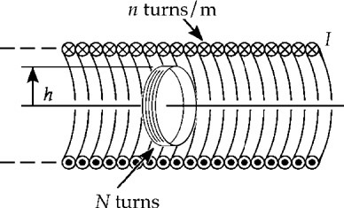

**ANS. FIG. P30.4**

**P30.5** The symbol for the radius of the ring is *r*1, and we use *R* to represent its resistance. The emf induced in the ring is



Note that A must be interpreted as the area *A* =  of the solenoid, where the field is strong:

**



(a) The negative sign means that the current in the ring is counter clockwise, opposite to the current in the solenoid. Its magnitude is



(b) 

(c) The solenoid’s field points to the right through the ring, and is

increasing, so to oppose the increasing field, *B*ring points to the 

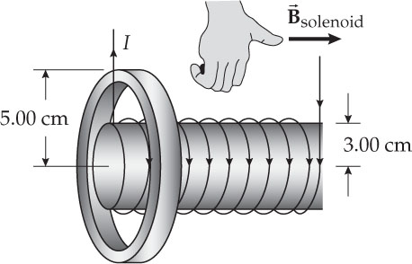

**ANS. FIG. P30.5**

**P30.6** See ANS. FIG. P30.5. The emf induced in the ring is



(a)  counter clockwise as viewed from the left end.

(b) 

(c) The solenoid’s field points to the right through the ring, and is increasing, so to oppose the increasing field, *B*ring points to the 

**P30.7** Faraday’s law, , becomes here



The magnitude of the emf is



The area is





Each side of the coil has length , so the total length of the wire is



**P30.8** (a) Suppose, first, that the central wire is long and straight. The enclosed current of unknown amplitude creates a circular magnetic field around it, with the magnitude of the field given by Ampère’s law.

: 

at the location of the Rogowski coil, which we assume is centered on the wire. This field passes perpendicularly through each turn of the toroid, producing flux



The toroid has 2 *π* *Rn* turns. As the magnetic field varies, the emf induced in it is



This is an alternating voltage with amplitude  Measuring the amplitude determines the size *I*max of the central current. Our assumptions that the central wire is long and straight and passes perpendicularly through the center of the Rogowski coil are all unnecessary.

(b) If the wire is not centered, the coil will respond to stronger magnetic fields on one side, but to correspondingly weaker fields on the opposite side. The emf induced in the coil is proportional to the line integral of the magnetic field around the circular axis of the toroid. Ampère’s law says that this line integral depends only on the amount of current the coil encloses. It does not depend on the shape or location of the current within the coil, or on any currents outside the coil.

**P30.9** In a toroid, all the flux is confined to the inside of the toroid. From Equation 29.16, the field inside the toroid at a distance *r* from its center is



The magnetic flux is then



and the induced emf is



Substituting numerical values and suppressing units,





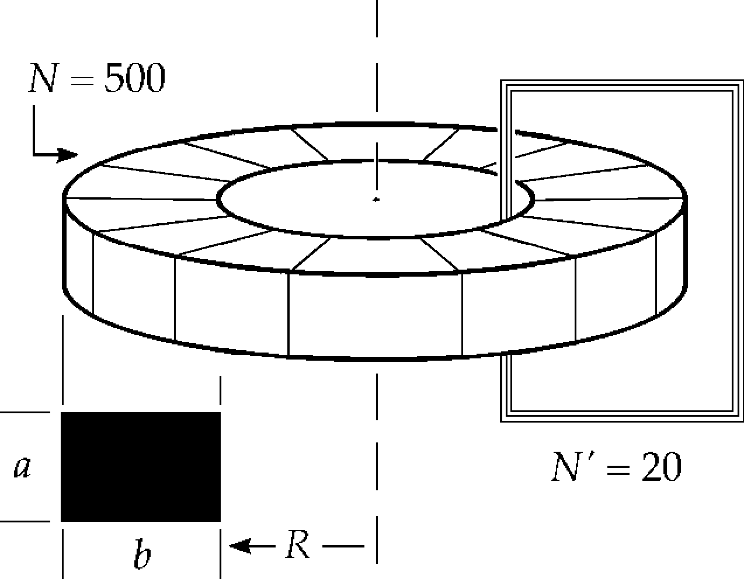

**ANS. FIG. P30.9**

Section 30.2 Motional emf

**P30.10** (a) The potential difference is equal to the motional emf and is given by



(b) A free positive test charge in the wing feels a magnetic force in direction  = (north) × (down) = (west): it migrates west. The wingtip on the pilot’s left is positive.

(c) . A positive test charge in the wing feels a magnetic force in direction  = (east) × (down) = (north): it migrates north. The left wingtip is north of the pilot.

(d) 

**P30.11** The angular speed of the rotor blades is



Thus, the motional emf is then



**P30.12** ((a) The motional emf induced in a conductor is proportional to the component of the magnetic field perpendicular to the conductor and to its velocity; in this case, the vertical component of the  
Earth’s magnetic field is perpendicular to both. Thus, the magnitude of the motional emf induced in the wire is



(b) Imagine holding your right hand horizontal with the fingers pointing north (the direction of the wire’s velocity), such that when you close your hand the fingers curl downward (in the direction of ). Your thumb will then be pointing westward. By the right-hand rule, the magnetic force on charges in the wire would tend to move positive charges westward. 

**P30.13** With *v* representing the initial speed of the bar, let *u* represent its speed at any later time. The motional emf induced in the bar is  The induced current is  The magnetic force on the bar is backward 

Method one: To find *u* as a function of time, we separate variables thus:





The distance traveled is given by



Method two: Newton’s second law is



Direct integration from the initial to the stopping point gives



**P30.14** To maximize the motional emf, the automobile must be moving east or west. Only the component of the magnetic field to the north generates an emf in the moving antenna. Therefore, the maximum motional emf is



Let’s solve for the unknown speed of the car:



Substitute numerical values:



This is equivalent to about 640 km/h or 400 mi/h, much faster than the car could drive on the curvy road and much faster than any standard automobile could drive in general.

**P30.15** (a) The motional emf induced in the bar must be  where *I* is the current in this series circuit. Since  the speed of the moving bar must be



(b) The flux through the closed loop formed by the rails, the bar, and the resistor is directed into the page and is increasing in magnitude. To oppose this change in flux, the current must flow in a manner so as to produce flux out of the page through the area enclosed by the loop. This means the current will flow .

(c) The rate at which energy is delivered to the resistor is



(d) 

**P30.16** (a) The induced emf is  where *B* is the magnitude of the component of the magnetic field perpendicular to the tether, which, in this case, is the vertical component of the Earth’s magnetic field at this location:



(b) 

(c) 

**\*P30.17** **Conceptualize** Imagine the disk divided up into a huge number of infinitesimal slices of radius *r* and angle *d*, such as the one shown below, where we are viewing the disk along the magnetic field lines:

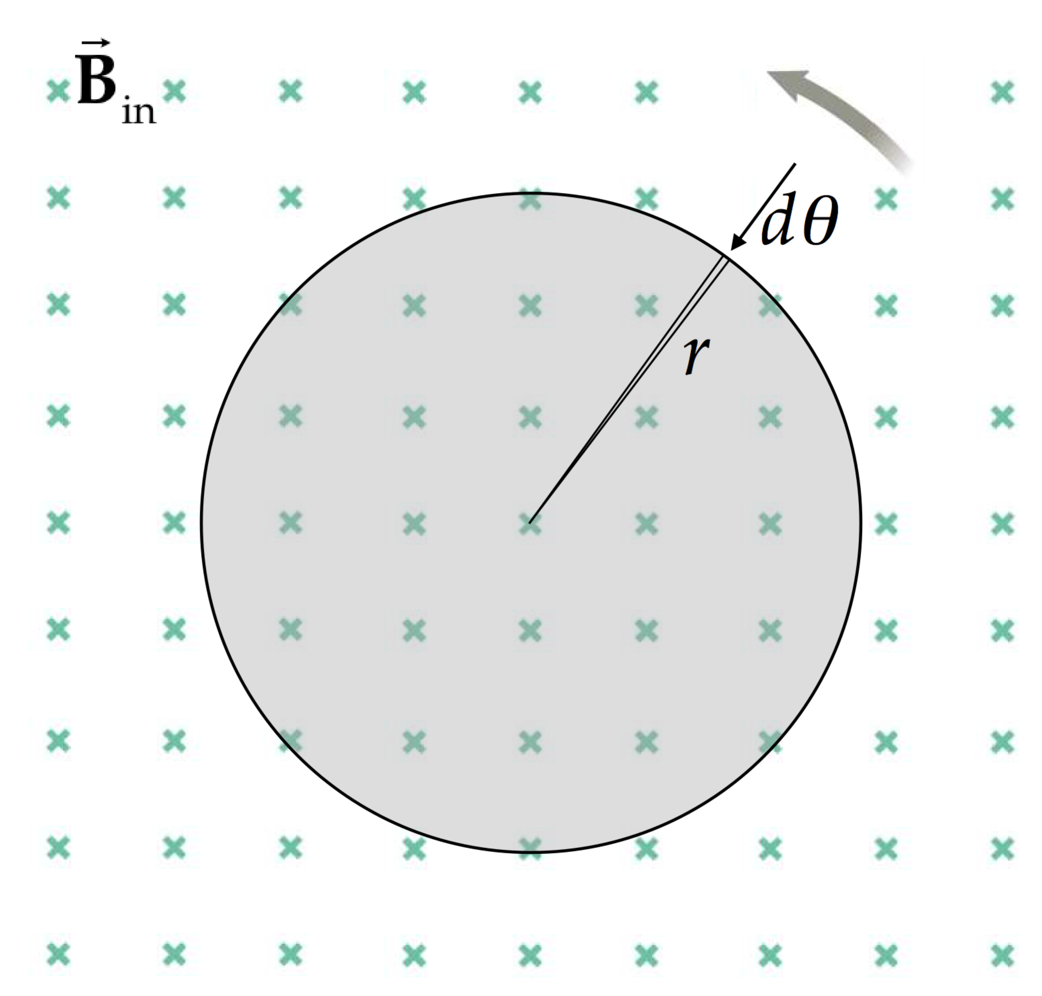

Now, compare the slice in the figure to the bar in Figure 30.10. It’s exactly the same situation! Therefore, we can use the results of Example 30.3 here.

**Categorize** The slice of metal in the figure is moving through a magnetic field, so we will use what we have learned about motional emf.

**Analyze** From the results of Example 30.3, the emf generated over the length of the slice, which is the radius *r* of the disk, is

 (1)

Solve Equation (1) for the angular speed:

 (2)

Substitute numerical values:



**Finalize** The 25.0 V is generated in *every* infinitesimal slice. Therefore, the disk is similar to a bank of 25.0-V batteries all connected in parallel. This is why the generator can provide a very high current to a load: it’s equivalent to a *huge* number of batteries!]

*Answer:* 3.32 × 103 rev/min

**\*P30.18 Conceptualize** The analysis will be similar to that in Section 30.2, with the added twist that the magnetic field is not uniform. The flux through a given element of the area of the loop will vary with position. In addition, the force on a given element of the bar will vary with position.

**Categorize** Because we want the bar to slide at a constant speed, it will modeled as a *particle in equilibrium*.

**Analyze** We cannot use any of the results in Section 30.2, because these were generated assuming that the field across the rails was uniform. But we can follow a similar analysis, being careful to allow for the varying field. Let’s begin by looking at a small element of the area enclosed by the loop consisting of the bar, the resistor, and the rails, shown in red below:

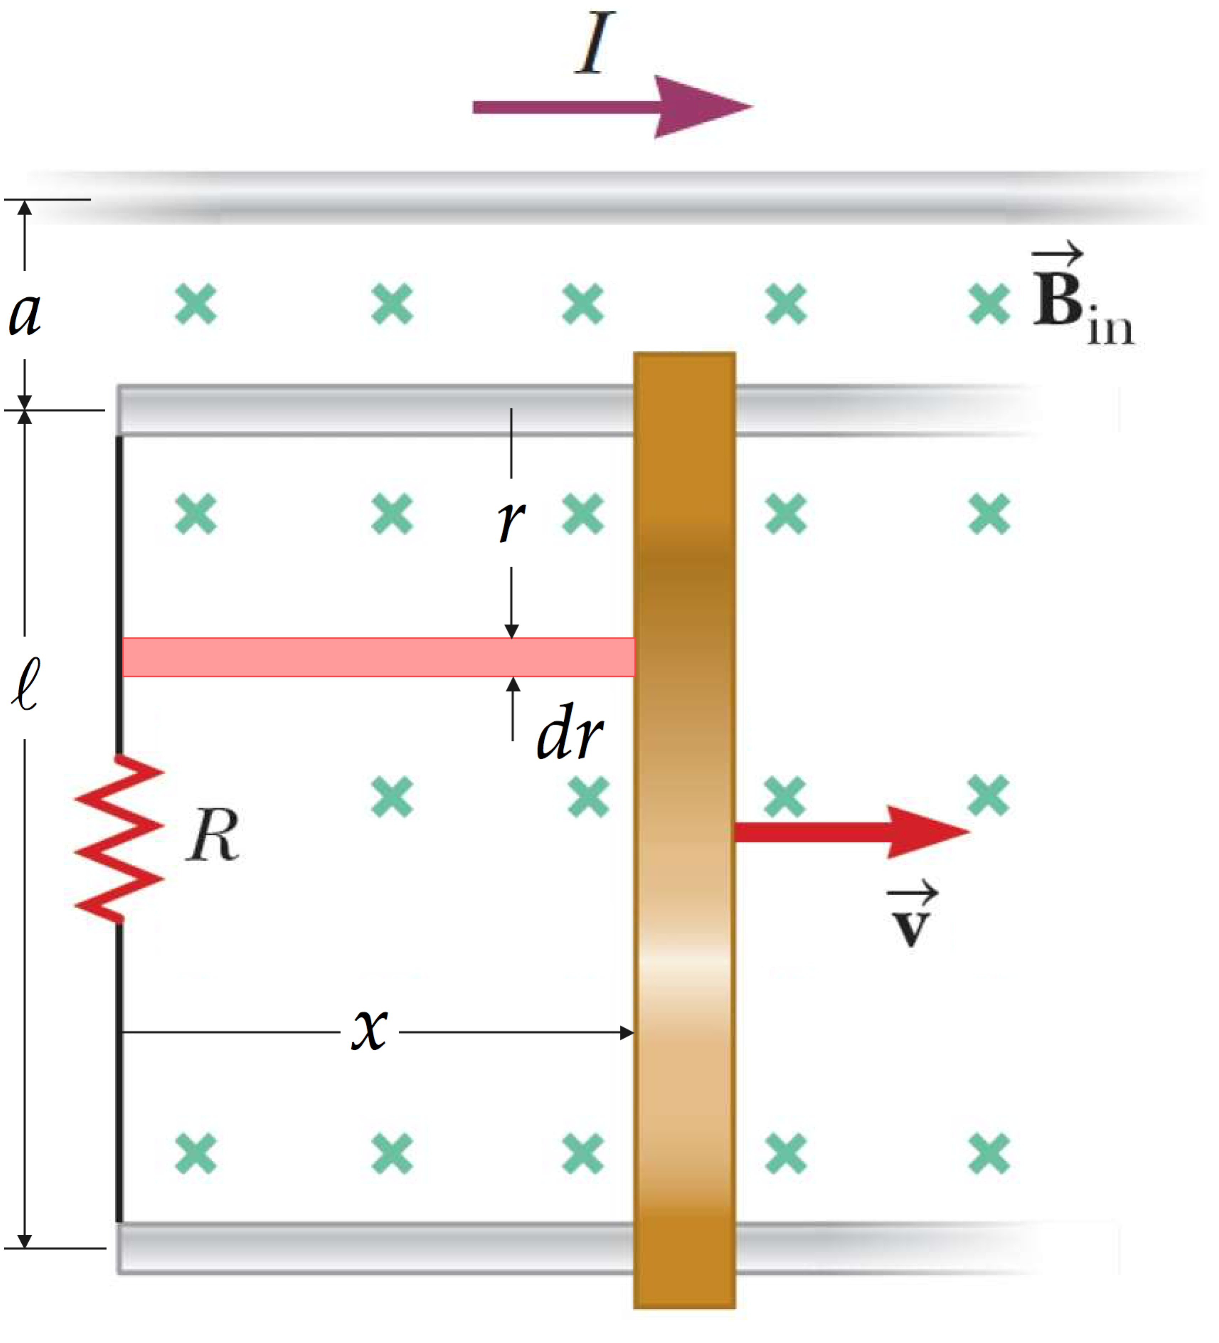

Use Equation 29.18 to evaluate the flux through the entire loop by evaluating the flux through the element of area and integrating:

 (1)

Use Equation 29.14 for the magnetic field due to the current *I* in the long, straight wire:

 (2)

Perform the integration:

 (3)

Now, from Faraday’s law, Equation 30.1, find the emf generated in the bar when it slides at speed *v*:

 (4)

From Equation 26.7, find the current in the loop, which is also the current in the bar:

 (5)

We use the subscript “bar” to differentiate this current from the current *I* in the long, straight wire. Identify an infinitesimal length *dr* of the bar, located at a distance *r* from the upper rail in Figure P30.18, shown in red below:

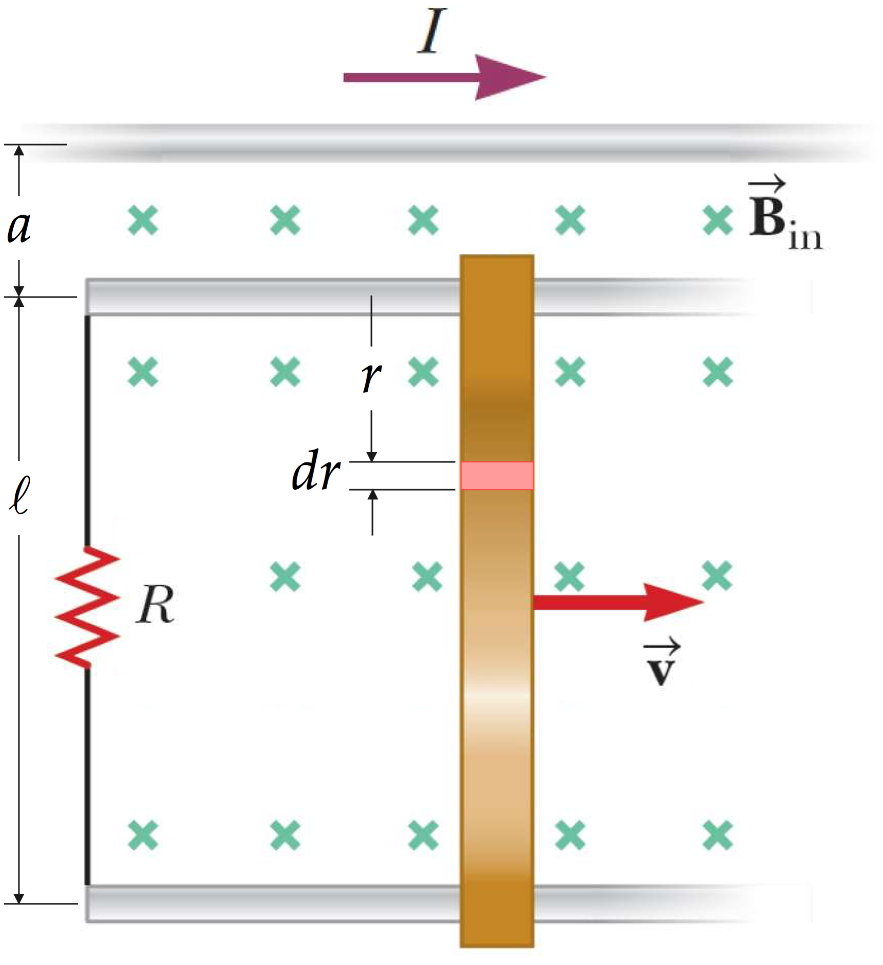

Set up a force equation from the particle in equilibrium model for this length of the bar:

 (6)

The magnetic force on this element of length is, from Equation 28.10,

 (7)

where *I*bar is given by Equation (5). Substitute Equation (5) for the current and Equation 29.14 again for the magnetic field magnitude:

 (8)

Integrate Equation (8) over the length of the bar:

 (9)

**Finalize** From the particle in equilibrium model, the result in Equation (9) is the total applied force on the bar to keep it moving at speed *v*. Notice that, even though we must perform two integrations in this problem, both integrals are the same!]

Answer: 

**\*P30.19** **Conceptualize** FigureP30.19shows the physical setup of the rails, resistor and bar. The magnetic field is directed downward, in the same direction as the gravitational field.

**Categorize** The bar is modeled as a *particle under a net force*. However, the request for a maximum speed suggests that we want to find the terminal speed of the bar. If it is traveling at a constant terminal speed, the bar is a *particle in equilibrium*.

AnalyzeThe diagram below shows a side view of the system. The resistor is going into the page and is not shown.

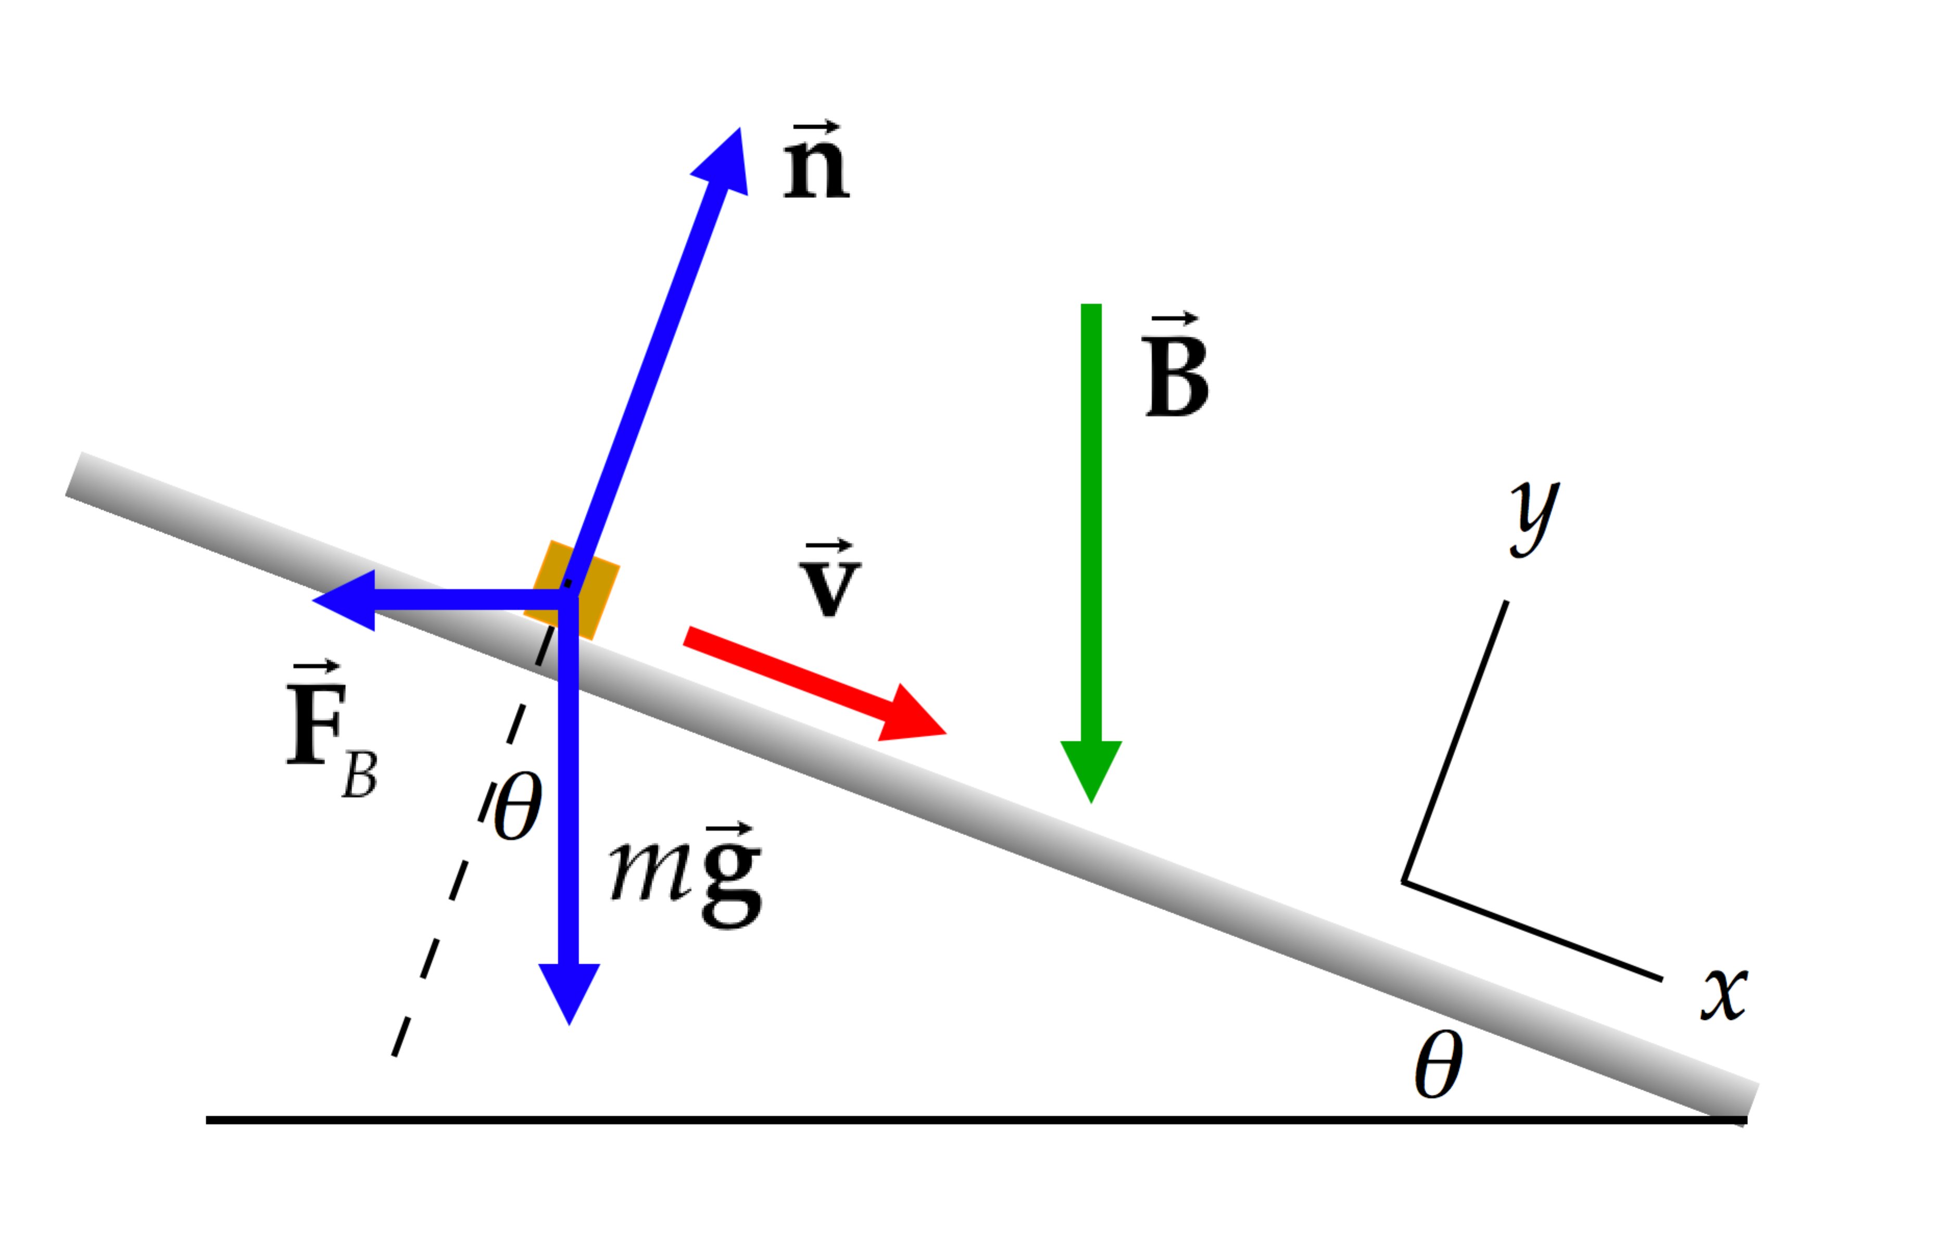

Write out an equation for the net force applied to the bar, in the direction parallel to the rails:

 (1)

From Equation 28.10, because the direction of the current (into the page) is perpendicular to the direction of the magnetic field,

 (2)

The current is induced by the component of the velocity of the bar perpendicular to the magnetic field, so

 (3)

Substitute Equation (3) into Equation (2) and the result into Equation (1):

 (4)

The terminal speed will occur when the net force is zero and the bar moves at a constant speed as a particle in equilibrium. Set the net force in Equation (4) equal to zero and solve for the magnetic field:

(5)

Substitute numerical values:



**Finalize** We described both the bars and the rails as “smooth,” suggesting that we ignore friction. How would the analysis differ if there were a constant friction force *fk* acting on the bars? Show that the terminal speed would be



so that the bars would arrive at the bottom at an even lower speed for a given magnetic field *B*.]

*Answer:* 1.00 T

**\*P30.20** **Conceptualize** Figure P30.19shows the physical setup of the rails, resistor and bar. The magnetic field is directed downward, in the same direction as the gravitational field.

**Categorize** The bar is modeled as a *particle under a net force.*

**Analyze** The diagram below shows a side view of the system. The resistor is going into the page and is not shown.



Write out an equation for the net force applied to the bar, in the direction parallel to the rails:

 (1)

From Equation 28.10, because the direction of the current (into the page) is perpendicular to the direction of the magnetic field,

 (2)

The current is induced by the component of the velocity of the bar perpendicular to the magnetic field, so

 (3)

Substitute Equation (3) into Equation (2) and the result into Equation (1):

 (4)

The terminal speed will occur when the net force is zero and the bar moves at a constant speed as a particle in equilibrium. Set the net force in Equation (4) equal to zero and solve for the magnetic field:



**Finalize** We described both the bars and the rails as “smooth,” suggesting that we ignore friction. How would the analysis differ if there were a constant friction force *fk* acting on the bars? Show that the terminal speed would be



so that the bars would arrive at the bottom at an even lower speed for a given magnetic field *B*.]

*Answer:*

Section 30.4 The General Form of Faraday’s Law

**P30.21** Point *P*1 lies outside the region of the uniform magnetic field. The rate of change of the field, in teslas per second, is



where *t* is in seconds. At *t* = 2.00 s, we see that the field is increasing:



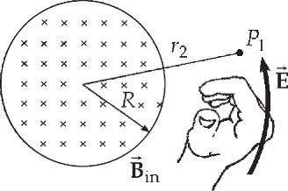

**ANS. FIG. P30.21**

The magnetic flux is increasing into the page; therefore, by the right-hand rule (see figure), the induced electric field lines are counter-clockwise. [Also, if a conductor of radius *r*1 were placed concentric with the field region, by Lenz’s law, the induced current would be counter clockwise. Therefore, the direction of the induced electric field lines are counter clockwise.] The electric field at point *P*1 is tangent to the electric field line passing through it.

(a) The magnitude of the electric field is



The magnitude of the force on the electron is



(b) Because the electron holds a negative charge, the direction of the force is opposite to the field direction. The force is tangent to the electric field line passing through at point *P*1 and clockwise.

(c) The force is zero when the rate of change of the magnetic field is zero:



**P30.22** A problem similar to this is discussed in Example 30.6.

(a)  where 



Solving for the electric field gives



Substituting numerical values and suppressing units,





(b) If a viewer looks at the solenoid along its axis, and if the current is increasing in the counter clockwise direction, the magnetic flux is increasing toward the viewer; the electric field always opposes increasing magnetic flux; therefore, by the right-hand rule, the electric field lines are .

Section 30.5 Generators and Motors

**P30.23** (The emf induced in a rotating coil is directly proportional to the angular speed of the coil. Thus,



or 

**P30.24** The induced emf is proportional to the number of turns and the angular speed.

(a) Doubling the number of turns has this effect:



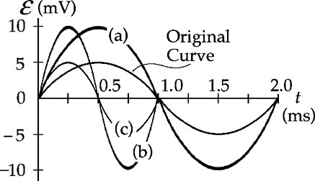

**ANS FIG. P30.24**

(b) Doubling the angular velocity has this effect:



(c) Doubling the angular velocity while reducing the number of turns to one half the original value has this effect:



**P30.25** (a) The flux through the loop is



(b) 

(c) 

(d) 

(e)  so 

**P30.26** Think of the semicircular conductor as enclosing half a coil of area  There is no emf induced in the conductor until the magnetic flux through the area of the coil begins to change. The conductor is in the field region for only half a turn, so the flux changes over half a period  If we consider *t* = 0 to correspond to the time when the conductor is in the position shown in Figure **P30.**26 of the textbook, then there is no change in flux for a quarter of a turn, from *t* = 0 to , then the flux has a periodic behavior  for a half a turn, from  to , then there is no change in flux for the final quarter of a turn, from  to , at the end of which the coil has returned to its starting position. While in the field region, the induced emf is



(a) The maximum emf is



(b) During the time period that the coil travels in the field region, the emf varies as  for half a period, from  at , to  at ; therefore, the average emf is 

(c) The flux could also be written as  so that it is a maximum at *t* = 0, but, in this case, the time period over which the flux changes would be from *t* = 0 to , and the amplitude of the emf and its average would be the same as in the previous case; therefore, 

(d) The graph is

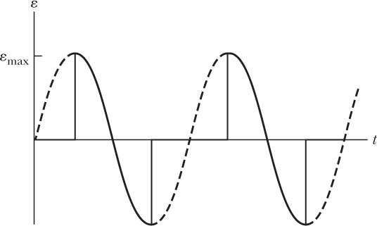

**ANS. FIG. P30.26 (d)**

(e) If the time axis is chose so that the maximum emf occurs at the same time as it does in the figure of part (d) the graph is

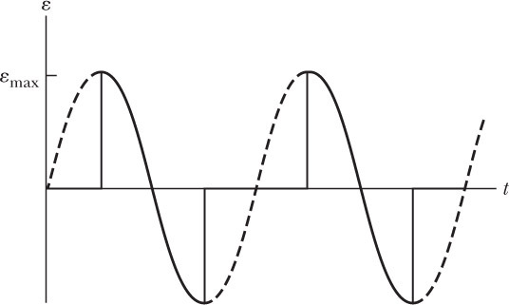

**ANS. FIG. P30.26 (e)**

Section 30.6 Eddy Currents

**P30.27** The current in the magnet creates an  upward magnetic field, so the N and S poles on the solenoid core are shown correctly. On the rail in front of the brake, the upward flux of  increases as the coil approaches, so a current is induced here to create a downward magnetic field. This is  clockwise current, so the S pole on the rail is shown correctly. On the rail behind the brake, the upward magnetic flux is decreasing. The induced current in the rail will produce upward magnetic field by being  counterclockwise as the picture correctly shows.

**Additional Problems**

**P30.28** Suppose we wrap twenty turns of wire into a flat compact circular coil of diameter 3 cm. Suppose we use a bar magnet to produce field  through the coil in one direction along its axis. Suppose we then flip the magnet to reverse the flux in 10–1 s. The average induced emf is then



**P30.29** The emf through the hoop is given by



where  is in volts and *t* in seconds. For *t* = 4.00 s,



**P30.30** The emf through the hoop is given by



**P30.31** The magnitude of the average emf is given by



The average current induced in the coil is therefore



**P30.32** (a) Motional emf produces a current 

(b) 

(c) The circuit encloses increasing flux of magnetic field into the page, so it tries to make its own field out of the page, by carrying counter clockwise current. The current flows upward in the bar, so the magnetic field produces a backward magnetic force  (to the left) on the bar. This force increases until the bar has reached a speed when the backward force balances the applied force *F*:



(d) 

(e) 

(f) 

(g) 

(h)  because the speed is proportional to the resistance, as shown in part (c).

(i) 

(j)  because the speed is greater.

**P30.33** 





**P30.34** Model the loop as a particle under a net force. The two forces on the loop are the gravitational force in the downward direction and the magnetic force in the upward direction. The magnetic force arises from the current generated in the loop due to the motion of its lower edge through the magnetic field. As the loop falls, the motional emf  induced in the bottom side of the loop produces a current   
*I* = *Bwv*/*R* in the loop. From Newton’s second law,



The largest possible value of *v*, the terminal speed *vT*, will occur when *ay* = 0. Set *ay* = 0 and solve for the terminal speed:



Substituting numerical values,



This is the highest speed the loop can have while the upper edge is above the field, so it cannot possibly be moving at 4.00 m/s.

**P30.35** The emf induced between the ends of the moving bar is



The left-hand loop contains decreasing flux away from you, so the induced current in it will be  clockwise, to produce its own field directed away from you. Let *I*1 represent the current flowing upward through the 2.00-Ω resistor. The right-hand loop will carry counter clockwise current. Let *I*3 be the upward current in the 5.00-Ω resistor.

(a) Kirchhoff’s loop rule then gives:

+7.00 V – *I*1 (2.00 Ω) = 0 or 

and +7.00 V – *I*3 (5.00 Ω) = 0 or 

(b) The total power converted in the resistors of the circuit is



(c) *Method 1*: The current in the sliding conductor is downward with value *I*2 = 3.50 A + 1.40 A = 4.90 A. The magnetic field exerts a force of  directed  toward the right on this conductor. An outside agent must then exert a force of  to the left to keep the bar moving.

*Method 2*: The agent moving the bar must supply the power according to  The force required is then:



**P30.36** (a)  where  so 

and the charge passing any point in the circuit will be .

(b) 

so 

**P30.37** The normal to the loop is horizontally north, at 35.0° to the magnetic field. We assume that 0.500  is the total resistance around the circuit, including the ammeter.





**P30.38** (a) To find the induced current, we first compute the induced emf,

.

Then,



(b) The applied force must balance the magnetic force



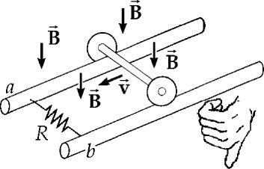

**ANS. FIG. P30.38**

(c) Since the magnetic flux  between the axle and the resistor is in effect decreasing, the induced current is clockwise so that it produces a downward magnetic field to oppose the decrease in flux: thus, current flows through *R* from *b* to *a*.  is at the higher potential.

(d) . Magnetic flux will increase through a loop between the axle and the resistor to the left of *ab*. Here counter clockwise current will flow to produce an upward magnetic field to oppose the increase in flux. The current in *R* is still from *b* to *a*.

**P30.39** (a) From Equation 30.3, the emf induced in the loop is given by



Substituting numerical values,



The minus sign indicates that the induced emf produces clockwise current, to make its own magnetic field into the page.

(b) At this instant,



The arc *PQ* has length



The length of the circuit is

0.500 m + 0.500 m + 0.250 m = 1.25 m

Its resistance is



The current is then



**P30.40** At a distance *r* from wire, . Using  we find that



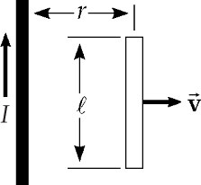

**ANS. FIG. P30.40**

**P30.41** (a) We would need to know whether the field is increasing or decreasing.

(b) To find the resistance at maximum power, we note that



Solving for the resistance then gives



(c) 

**P30.42** The emf induced in the loop is



(a) The charge on the fully-charged capacitor is



(b)  into the paper is decreasing; therefore, current will attempt to counteract this by producing a magnetic field into the page to oppose the decrease in flux. To do this, the current must be clockwise, so positive charge will go to the .

(c) 

**P30.43** (a) The time interval required for the coil to move distance  and exit the field is , where *v* is the constant speed of the coil. Since the speed of the coil is constant, the flux through the area enclosed by the coil decreases at a constant rate. Thus, the instantaneous induced emf is the same as the average emf over the interval  or



(b) The current induced in the coil is



(c) The power delivered to the coil is given by *P* = *I*2*R*, or



(d) The rate that the applied force does work must equal the power delivered to the coil, so  or



(e) As the coil is emerging from the field, the flux through the area it encloses is directed into the page and decreasing in magnitude. Thus, the *change* in the flux through the coil is directed out of the page. The induced current must then flow around the coil in such a direction as to produce flux into the page through the enclosed area, opposing the change that is occurring. This means that the current must flow  around the coil.

(f) As the coil is emerging from the field, the left side of the coil is carrying an induced current directed toward the top of the page through a magnetic field that is directed into the page. By the right-hand rule, this side of the coil will experience a magnetic force , opposing the motion of the coil.

**P30.44** The magnetic field at a distance *x* from wire is



The emf induced in an element in the bar of length *dx* is  The total emf induced along the entire length of the bar is then



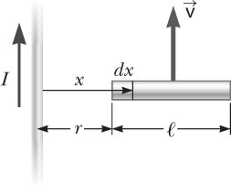

**ANS. FIG. P30.44**

**P30.45** The magnetic field produced by the current in the straight wire is perpendicular to the plane of the coil at all points within the coil. At a distance *r* from the wire, the magnitude of the field is . Thus, the flux through an element of length *L* and width *dr* is

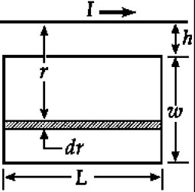

**ANS. FIG. P30.45**



The total flux through the coil is



Finally, the induced emf is



The term  in the expression for the current in the straight wire does not change appreciably when *ω t* changes by 0.10 rad or less. Thus, the current does not change appreciably during a time interval



We define a critical length,



equal to the distance to which field changes could be propagated during an interval of 1.6 × 10–4 s. This length is so much larger than any dimension of the coil or its distance from the wire that, although we consider the straight wire to be infinitely long, we can also safely ignore the field propagation effects in the vicinity of the coil. Moreover, the phase angle can be considered to be constant along the wire in the vicinity of the coil.

If the angular frequency *ω* were much larger, say, 200*π* × 105 s–1, the corresponding critical length would be only 48 cm. In this situation propagation effects would be important and the above expression for  would require modification. As a general rule we can consider field propagation effects for circuits of laboratory size to be negligible for frequencies, , that are less than about 106 Hz.

**P30.46** The magnetic field at a distance *x* from a long wire is . We find an expression for the flux through the loop.



so 

Therefore,



and 

**P30.47** (a) The induced emf is  where , ,   
*vf* = *vi* + *gt* = 9.80*t*, and  where *I* is in amperes,  and *y* are in meters, *v* is in meters per second, and *t* in seconds.

Thus,



where  is in volts and *t* in seconds.

(b) The emf is zero when *t* = 0.

(c) As ,  and the emf diverges to .

(d) At *t* = 0.300 s,



**Challenge Problems**

**P30.48** (a) Consider an annulus of radius *r*, width *dr*, thickness *b*, and resistivity *ρ*. Around its circumference, a voltage is induced according to



The resistance around the loop is  The eddy current in the ring is



The instantaneous power is



The time average of the function  is , so the time-averaged power delivered to the annulus is



The average power delivered to the disk is 



(b) When *B*max doubles,  and *P* become  times larger.

(c) When *f* doubles,  doubles, and  and *P* become  times larger.

(d) When *R* doubles, *R*4 and *P* become  times larger.

**P30.49** The current in the rod is

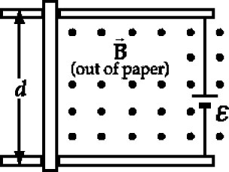

**ANS. FIG. P30.49**



where  because the induced emf opposes the emf of the battery. The force on the rod is related to the current and the velocity:





To solve the differential equation, let 



Integrating from *t* = 0 to *t* = *t* gives  or 

Since *v* = 0 when *t* = 0,  substituting  gives



Therefore, 

**P30.50** Suppose the magnetic field is vertically down. When an electron is moving away from you the force on it is in the direction given by

 as – (away) × (down) = –  = – (left) = (right)

Therefore, the electrons circulate clockwise.

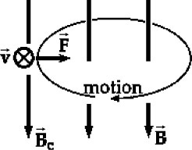

**ANS. FIG. P30.50**

(a) As the downward field increases, an emf is induced to produce some current that in turn produces an upward field to oppose the increasing downward field. This current is directed 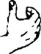 counterclockwise, carried by negative electrons moving clockwise. Therefore the electric force on the electrons is clockwise and the original electron motion speeds up.

(b) At the circumference, we have



where *Bc* is the magnetic field at the circle’s circumference.

The increasing magnetic field  in the area enclosed by the orbit produces a tangential electric field according to



or



Using this expression for *E*, we find the tangential force on the electron:



If the electron starts at rest and increases to final speed *v* as the magnetic field builds from zero to final value *Bav*, then integration of the last equation gives



Thus, from the two expressions for *mv*, we have  

**P30.51** For the suspended mass, *M*:



For the sliding bar, *m*:

 where 

Substituting the expression for current *I*, the first equation gives us



The above equation can be written as

 where  and 

Integrating,



Then,



Solving for *v* gives



|  |
| --- |
| **ANSWERS TO QUICK-QUIZZES** |

1. (c)
2. (c)
3. (b)
4. (a)

|  |
| --- |
| **ANSWERS TO EVEN-NUMBERED PROBLEMS** |

**P30.2** (a) Each coil has a pulse of voltage tending to produce counterclockwise current as the projectile approaches, and then a pulse of clockwise voltage as the projectile recedes; (b) 625 m/s

**P30.4**  where *t* is in seconds and  is in mV

**P30.6** (a)  (b) ; (c) left

**P30.8** (a) See P30.8 (a) for full explanation; (b) The emf induced in the coil is proportional to the line integral of the magnetic field around the circular axis of the toroid. Ampère’s law says that this line integral depends only on the amount of current the coil encloses.

**P30.10** (a) 11.8 mV; (b) The wingtip on the pilot’s left is positive; (c) no change; (d) No. If you try to connect the wings to a circuit containing the light bulb, you must run an extra insulated wire along the wing. In a uniform field the total emf generated in the one-turn coil is zero.

**P30.12** (a) 39.9 mV (b) The west end is positive.

**P30.14** The speed of the car is equivalent to about 640 km/h or 400 mi/h, much faster than the car could drive on the curvy road and much faster than any standard automobile could drive in general.

**P30.16** (a) 6.00 *µ*T; (b) Yes. The magnitude and direction of the Earth’s field varies from one location to the other, so the induced voltage in the wire changes. Furthermore, the voltage will change if the tether cord or its velocity changes their orientation relative to the Earth’s field;   
(c) Either the long dimension of the tether or the velocity vector could be parallel to the magnetic field at some instant.

**P30.18** 

**P30.20** 

**P30.22** (a) 

(b) clockwise

**P30.24** (a) amplitude doubles and period is unchanged; (b) doubles the amplitude and cuts the period in half; (c) amplitude unchanged and period is cut in half

**P30.26** (a) 1.60 V; (b) zero; (c) no change in either answer; (d) See ANS. FIG. P30.26 (d); (e) See ANS. FIG. P30.26 (e).

**P30.28** ~10–4 V

**P30.30** 3.79 mV

**P30.32** (a) ; (b) particle in equilibrium; (c) 281 m/s; (d) 1.88 A; (e) 169 W; (f) 169 W; (g) yes; (h) increase; (i) yes; (j) larger

**P30.34** 3.92 m/s is the highest speed the loop can have while the upper edge is above the field, so it cannot possibly be moving at 4.00 m/s.

**P30.36** (a) See P30.36 (a) for full explanation; (b) 0.250 T

**P30.38** (a) 0.900 A; (b) 0.108 N; (c) Point *b*; (d) no

**P30.40** See P30.40 for full explanation.

**P30.42** (a)  (b) upper plate; (c) The changing magnetic field through the enclosed area of the loop induces a clockwise electric field within the loop, and this causes electric force to push on charges in the wire

**P30.44** See P30.44 for full explanation.

**P30.46** 

**P30.48** (a)  (b) 4; (c) 4; (d) 16

**P30.50** (a) See P30.50 (a) for full description; (b) See P30.50 (b) for full description.;